7. ReactJS-HOL
Cart.js
import React, { Component } from 'react';

class Cart extends Component {
render() {
return (
<tr>
<td>{this.props.itemname}</td>
<td>{this.props.price}</td>
</tr>
);
}
}

// Default props (optional fallback)
Cart.defaultProps = {
itemname: "Unknown Item",
price: "0"
};

export default Cart;

OnlineShopping.js
import React, { Component } from 'react';
import Cart from './Cart';

class OnlineShopping extends Component {
render() {
const items = [
{ itemname: 'Laptop', price: 80000 },
{ itemname: 'TV', price: 120000 },
{ itemname: 'Washing Machine', price: 50000 },
{ itemname: 'Mobile', price: 30000 },
{ itemname: 'Fridge', price: 70000 }
];

return (
<div style={{ textAlign: 'center' }}>
<h2 style={{ color: 'green' }}>Items Ordered :</h2>
<table border="1" align="center" cellPadding="10" style={{ borderCollapse: 'collapse' }}>
<thead>
<tr>
<th>Name</th>
<th>Price</th>
</tr>
</thead>
<tbody>
{items.map((item, index) => (
<Cart key={index} itemname={item.itemname} price={item.price} />
))}
</tbody>
</table>
</div>
);
}
}

export default OnlineShopping;

App.js
import React from 'react';
import ReactDOM from 'react-dom/client';
import App from './App';

const root = ReactDOM.createRoot(document.getElementById('root'));
root.render(<App />);

Index.js
import React from 'react';
import OnlineShopping from './OnlineShopping';

function App() {
return <OnlineShopping />;
}

export default App;

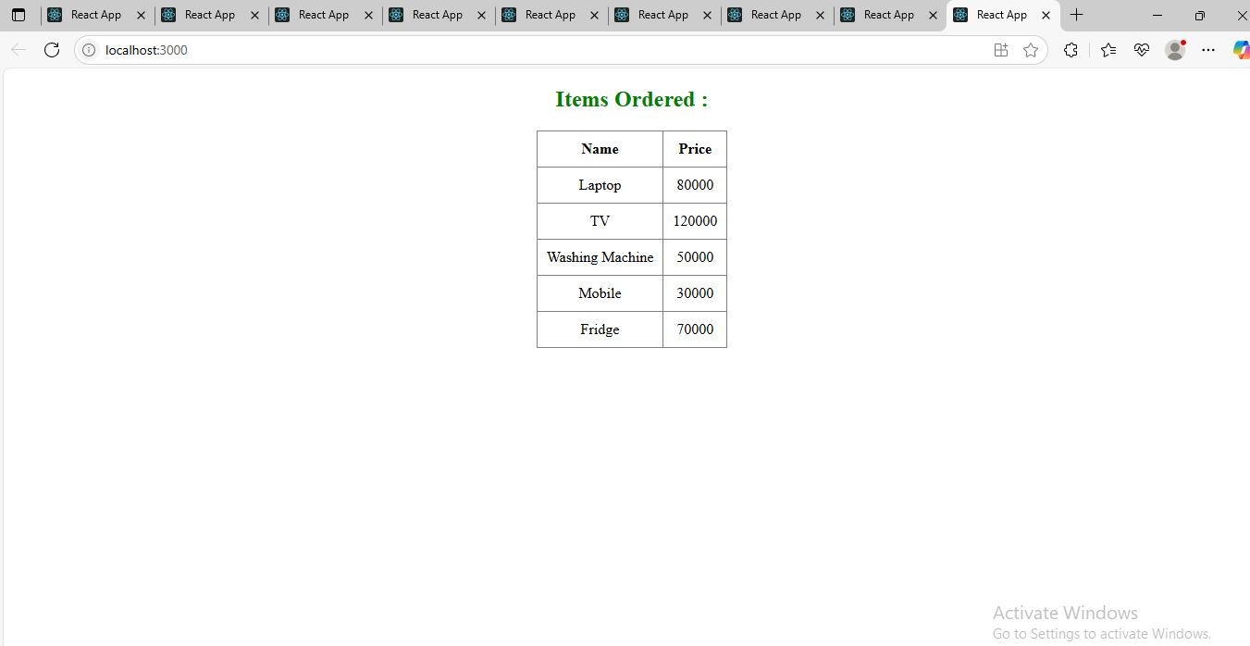
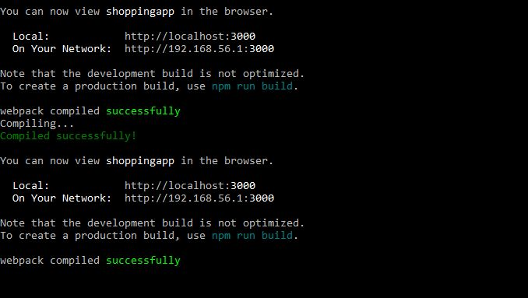

Define Props
Props (short for properties) are read-only attributes passed from a parent component to a child component in React.
They are used to pass data, functions, or configuration between components.
Example:
function Welcome(props) {
return <h1>Hello, {props.name}</h1>;
}
You can use this component like:
<Welcome name="Sajitha" />

Explain Default Props
Default props provide default values for props that are not passed by the parent component.
Example:
function Welcome(props) {
return <h1>Hello, {props.name}</h1>;
}

Welcome.defaultProps = {
name: "Guest"
};
If name is not provided, "Guest" will be used.

Identify the Differences Between State and Props
Feature | Props | State
Definition | Data passed from parent to child | Data managed inside the component
Mutability | Immutable (read-only) | Mutable (can be changed with setState)
Access | this.props (class) / props (func) | this.state / useState() (hook)
Purpose | Configuration and communication | Handling dynamic or interactive data
Ownership | External (from parent) | Internal (owned by the component)

Explain reactDOM.render()
ReactDOM.render() is the entry point to render a React component into the DOM. It tells React what to render and where to render it.
Syntax:
ReactDOM.render(<App />, document.getElementById('root'));
- <App /> → The component to render
- document.getElementById('root') → The target DOM element (usually in index.html)
From React 18 onwards, ReactDOM.createRoot(...).render(...) is used instead of ReactDOM.render().

